Structure Basics assignments

Mandatory
- WAP to define read and store the following details together in a structure and display the structure details
name – char* [input could of maximum length 50 char]
age – uint
designation – enum [use the enum values used in enum exercise]
void read (EMP *emp)
void display (EMP emp);

Implement additional function below.
//read and update the employee record
int update(EMP *emp);

//copy the emp to a new employee and return
EMP copy(EMP emp);
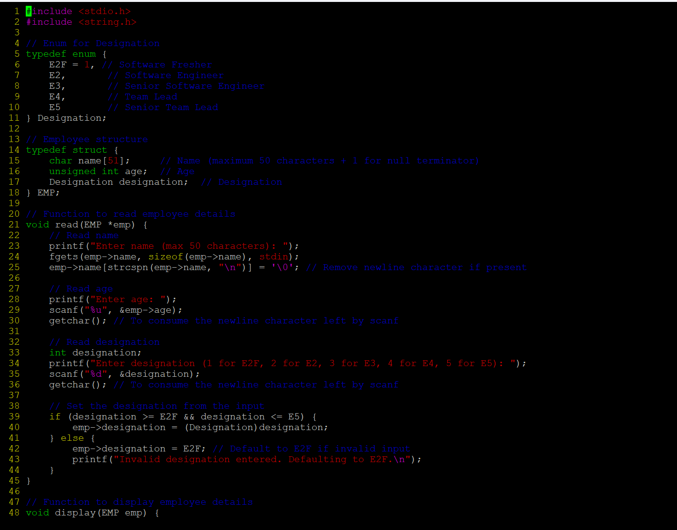

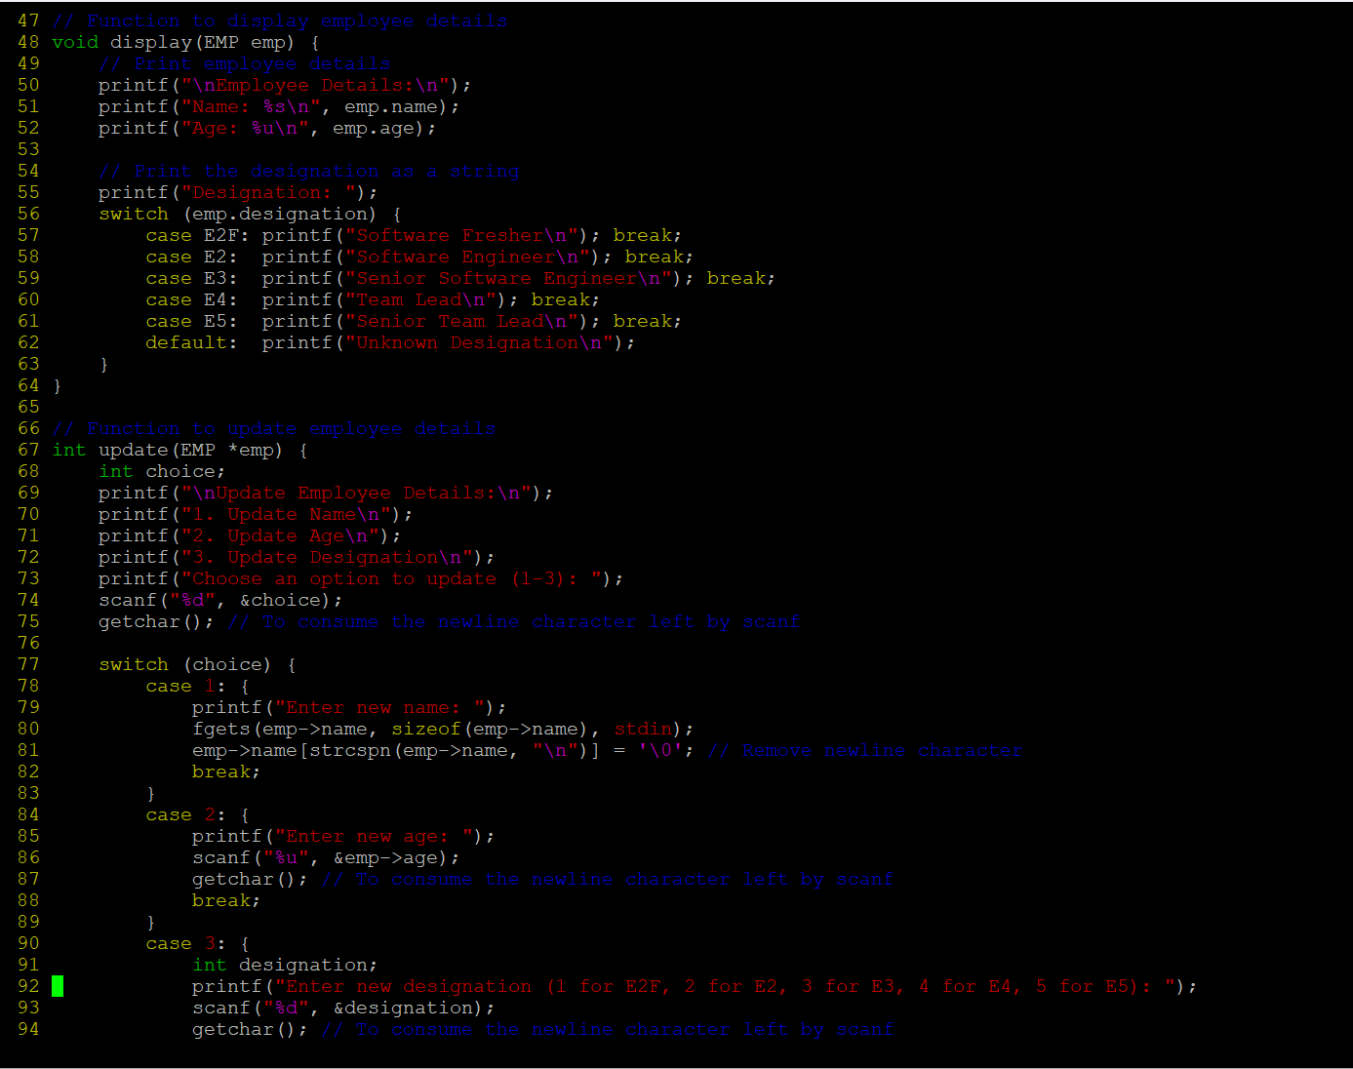

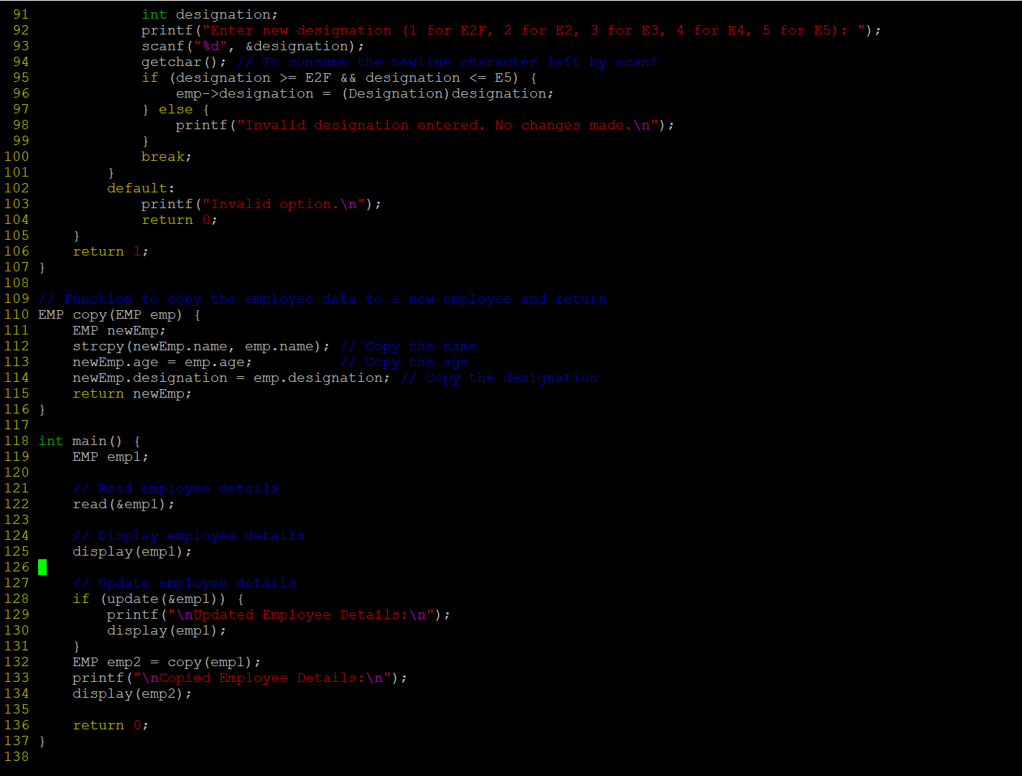
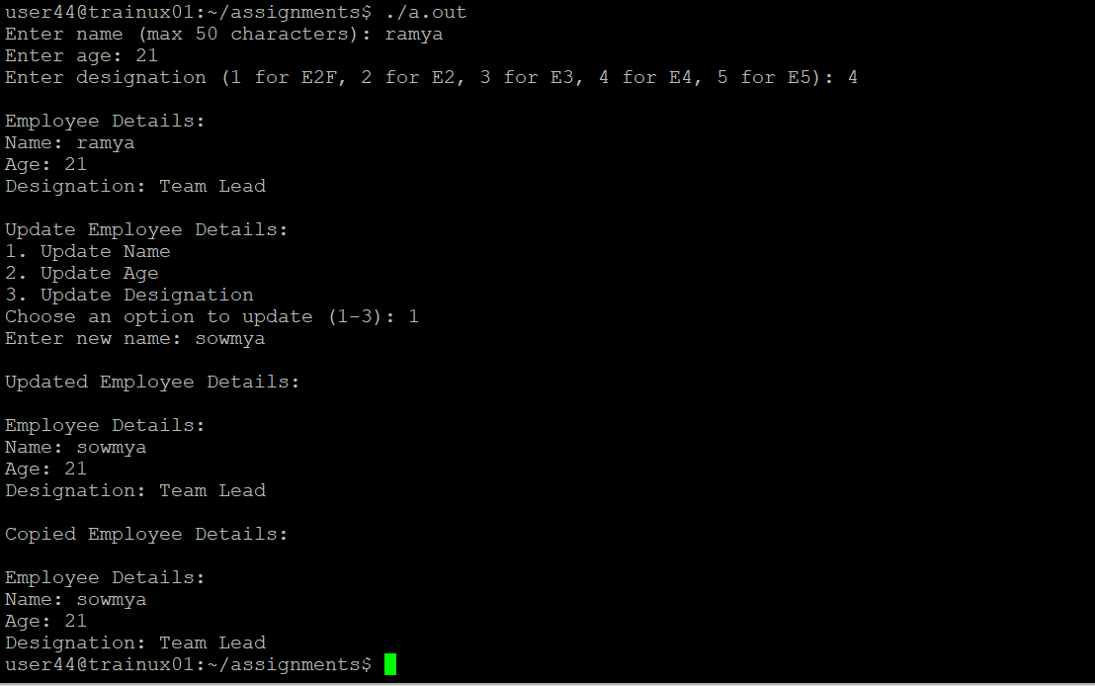

- Extend the above program and create and initialize an array of 3 structures. Reuse the read() and display() functions to read, initialize and display structures
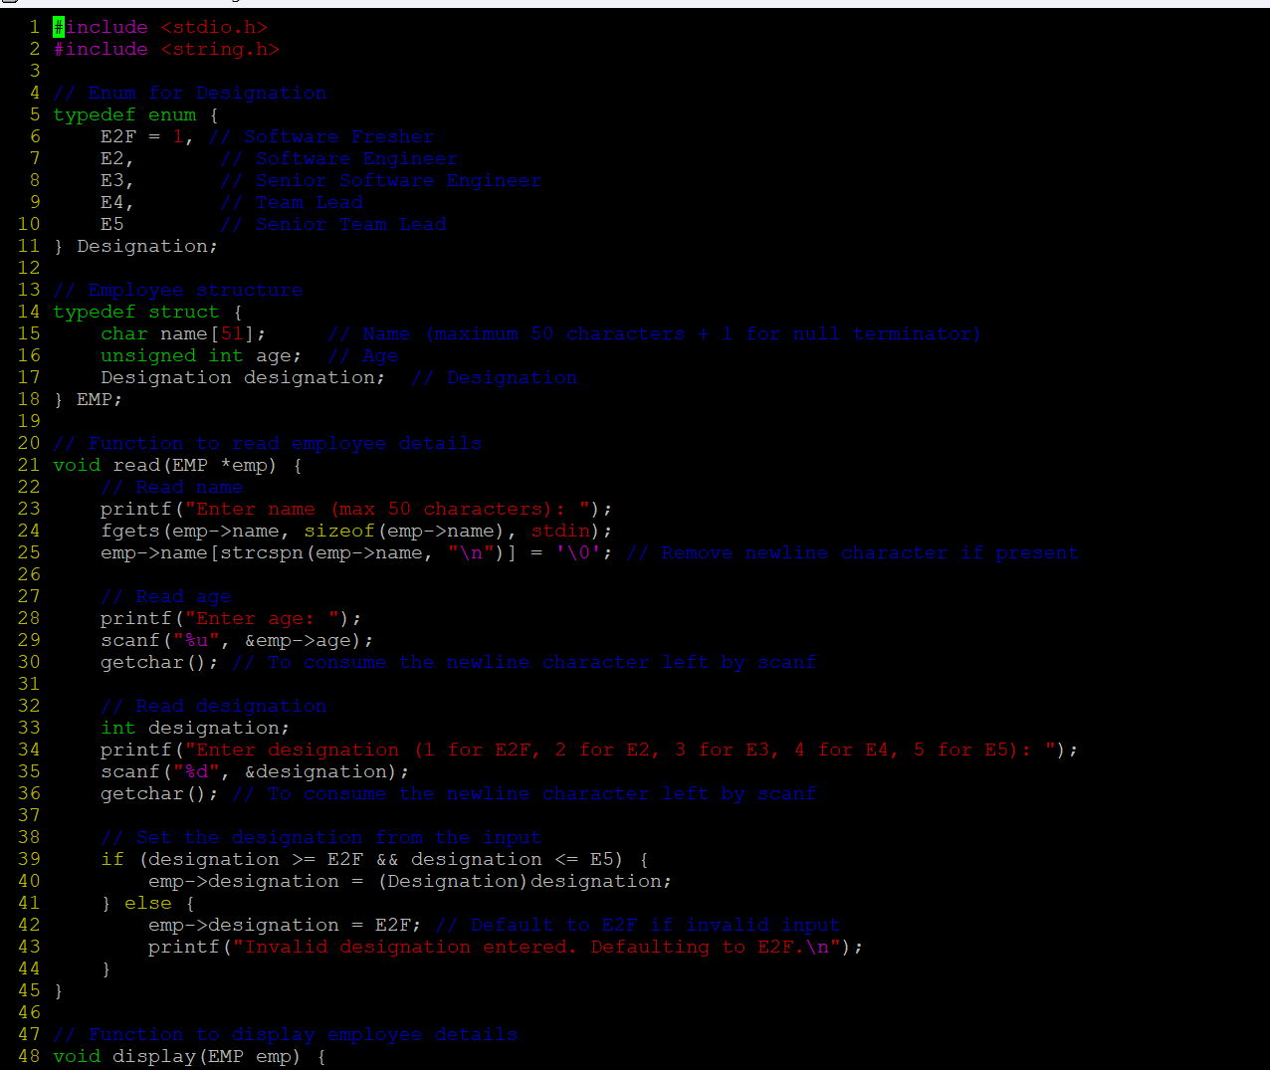
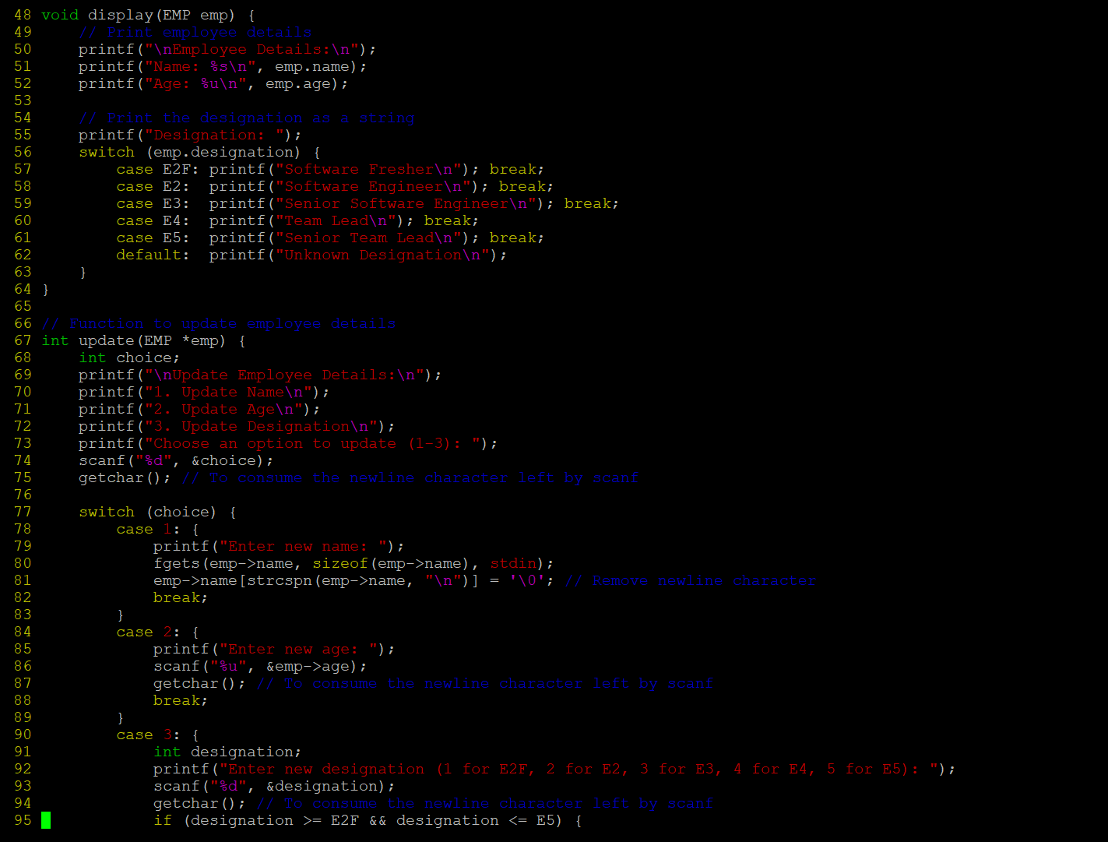

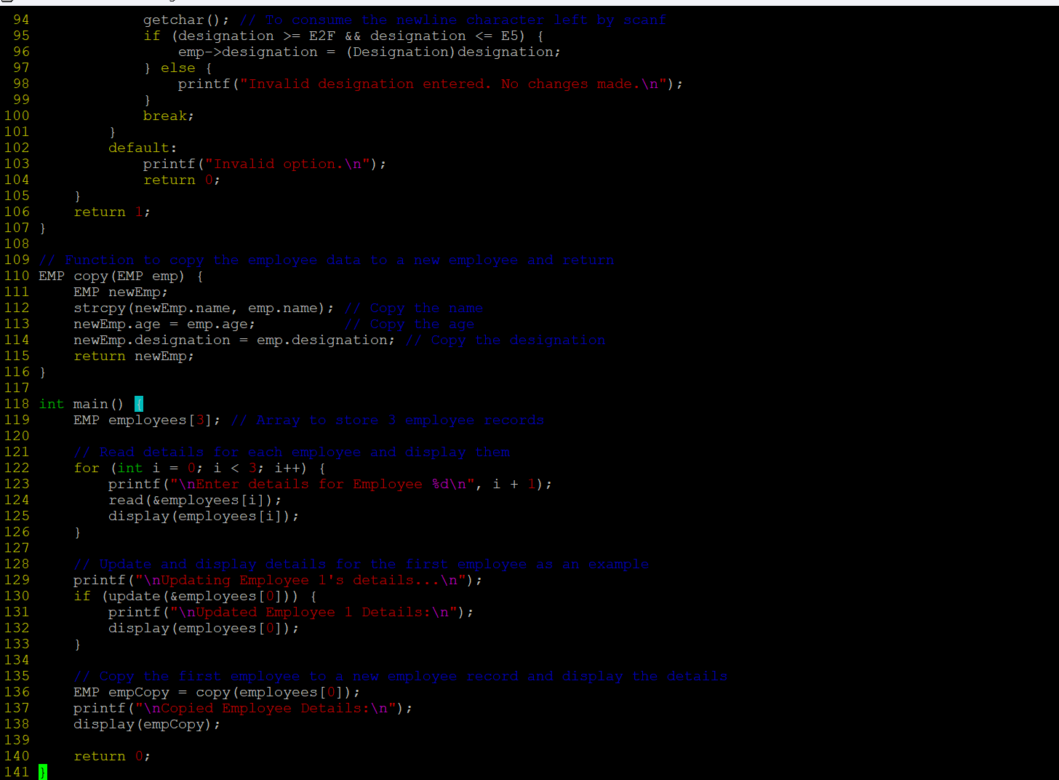

Output:
